Blended Intensive Program at Fontys School of Education – Health and Wellbeing
23rd International Summer School: in health promotion
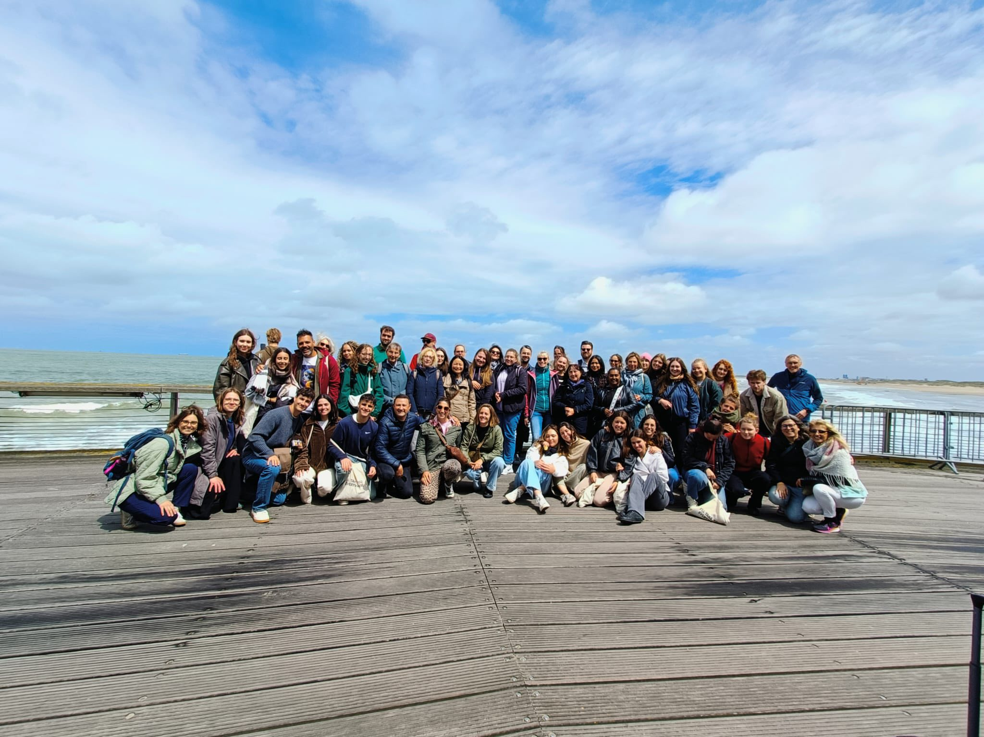
Foto: Summerschool Brugges, 2025

18 to 22 May 2026

Dear Summer School Participants,

We are delighted to welcome you to the 23rd International Summer School of Health Promotion. This event will be hosted by the Fontys School of Education at Fontys University of Applied Sciences, Health and Wellbeing, in The Netherlands, from May 18th to May 22nd, 2026.

The Summer School is organized in collaboration with:
- Poznan University of Medical Sciences, Poland
- Esslingen University of Applied Sciences, Germany
- Saarland University of Applied Sciences - School of Social Sciences, Germany
- HoWest, Hogeschool West-Vlanderen, University of Applied Sciences, Belgium
- University of Balearic Islands, Palma de Mallorca, Spain

The hosts of this week’s event are the lecturers Isabelle Kuijlenburg, Marieke van Asten, MA and Mücan Benli, MA and of course our wonderful team of students: Zerdanur Arslantas, Willemein Goedbloed, Audrey Turney, Linse van Dinteren, Joep Kruik, Lindy de Waal, Maartje Diphorn, Shama Sewlal and Wessel van Dam.

This year’s topic is:

Health equity in a changing world: embracing diversity and promoting digital inclusion as pillars of modern health promotion

Blended online meetings
* May 7 2026, 16.00-18.00 h:
- Introduction to the Summerschool organization and family
- First introduction to the topic of the week: Navigating Diversity and Inclusion in Healthcare in the AI era (Keynote speaker: Charlie Obihara)
* June 2, 2026, 16.00-18.00 h:
- Evaluation and discussion future Summerschool (2027) program

Monday 18 th of May 2026
Location: Bistro and Campus Fontys School for Education
Chair: geen chair deze dag
13.00h – 14.00h Walk in and opening speech
14.00h - 15.30h Group activities: Create your own culture – The tree of life
15.30h -15.45h Break
15.45h - 16.30h Campustour by Levent Önder
16.45h-17.00h Welcome speech by Frans Koevoets, Education Manager at Fontys Tilburg
17.00h Foodtruck on Campus

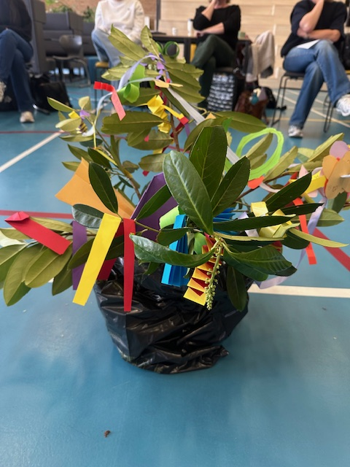
Foto: The tree of life created by a group in April 2024

Tuesday 19th of May
Location: start at Bistro (workshops in divers rooms: P1 B0.15, P1 B0.01, P1 A1.03, P1 A1.03)
9.30h - 10.15h Presentation and discussion Belgium (0:45h)
Chair: Dr. hab. Jan Domaradzki and MSN Antonio González Trujillo
Lecturer: Nele Huys
Topic: “Development of a digital application for young people with obesity, the use of
health apps and sustaining a healthy lifestyle.”
10.15h – 10.30h Discussion (Bistro)
10.30h - 10.45h Break
10.45h - 12.30h Presentation and workshops Spain (1:45h)
Chair: Prof. Reinhold Wolke and Prof. Dr. Vasiliki Kolovou, MPH
Topic: “Logged in, Locked out.”
Lecturers: Prof. Dr. Jesús Molina Mula, Dra. Maite Arbós Berenguer, Dra. Elisa Bosch
Donate, MSN Antonio González Trujillo
Students: Nadia Picó Llabrés, Francisco Espín Ureña, Ikram Mehadn Abdel-lah,
Sara Giraldo Pedrote, Margalida Plomer Capó, Francisca Maria Tortella Campomar,
Clara Vivo Berga, Fernando González Barreiro, Candela Roig Moll, Sara Puerto Jerez
12.30h - 12.45h Discussion (Bistro)
12.45h - 14.00h Lunch in B 007
15.00h - 17.00h Field trip to ETZ (program ETZ)
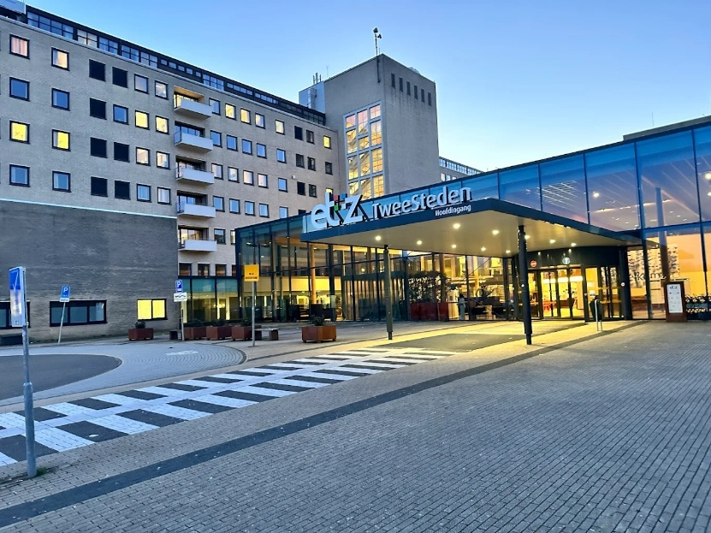
Address: ETZ Elizabeth– Twee Steden Ziekenhuis, Doctor Deelenlaan 5, 5042 AD Tilburg

Wednesday 20th of May
Location: Start Bistro (workshop in divers rooms: P1 B0.15, P1 B0.01, P1 A1.03, P1 A1.03)
9.30h - 11.00h Presentation and workshops Poland (1:30h)
Chair: Dra. Maite Arbós Berenguer and Isabelle Kuijlenburg
Topic: “From System to Society: Advancing Health Equity in Poland through Diversity
and Digital Innovation”
Lecturers: Dr. hab. Jan Domaradzki, Dr. hab. Ewelina Chawłowska, MA Julia Wolski
Students: Agata Buszka, Maria Cienki, Katarzyna Dębowiak, Maria Matuszewska,
Natalia Musiałowska, Zofia Rogowska, Manuela Stróżyk, Julia Surdacka,
Maria Szczudrawa, Zuza Zielińska
11.00h - 11.15h Discussion
11.15h - 11.30h Break
11.30h - 12.15h Presentation and discussion Germany Saarland (0:45h)
Chair: Prof. Dr. Jesús Molina Mula and Marieke van Asten
Topic: ''Loneliness as a health promotion challenge – digital bridges or digital walls?”
Lecturers: Prof. Dr. Dagmar Renaud, Dipl. Psych. and Prof. Dr. Vasiliki Kolovou, MPH
12.15h - 12.30h Discussion (Bistro)
12.30h - 14.00h Lunch in B 007
14.00h - 15.30h Presentation and workshops Esslingen, Germany (1:30h)
Chair: Dra. Elisa Bosch Donate and Prof. Dr. Dagmar Renaud
Topic: “Healthcare made in Germany. Digital opportunities.”
Lecturer: Prof. Reinhold Wolke
Students: Daniela Martin, Maili Huippula, Marven Matulla, Valentin Fischer,
Svenja Stuemmel, Ricardo Vieira-Wetzel, Florian Wiens, Zeliha Kaya, Linda Kloos
15.30h – 15.45h Discussion (Bistro)
15.45h – Free time (Also, quality time with ‘the family’)
19.00h Teacher dinner
External location:

Thursday 21st of May
Location: Start in Bistro (workshops divers rooms: P1 B0.15, P1 B0.01, P1 A1.03, P1 A1.03)
9.30h - 11.00h Presentation and workshops Netherlands (1:30h)
Chair: Dr hab. Ewelina Chawłowska, MA Julia Wolski
Topic: “Digitalization of education: examining the impact on inequality of opportunity and
the mental well-being of young people”
Lecturers: Isabelle Kuijlenburg, Marieke van Asten and Mücan Benli
Students: Zerdanur Arslantas, Willemein Goedebloed, Audrey Turney, Linse van
Dinteren, Joep Kruik, Lindy de Waal, Maartje Diphorn, Shama Sewlal, Wessel van Dam.
11.00h – 11.15h Discussion (Bistro)
11.15h – 11.30h Break
11.30h - 11.45h Speech Prof. Frans Vergeer
12.00h – 14.30h Lunch and break in B0.07
14.30h – 16.00h Workshop Carroussel: Mindfulness, Rock and Water, Bart Pardoel digital skills
16.30h – 17.45h Dinner at Fontys, Buffet style
19.00h – till late Farewell Party
Dress code: “Dress to impress in orange and/or purple!”
External location:

Friday 22th of May
Location: Mediatheek
10.00h - 11.00h Evaluation
11.00h – 12.00h Farewell Ceremony

